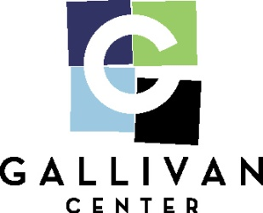

**Juneteenth Celebration**

**June 20, 2022**

**Vendor Rules & Guidelines**

**Pre-Event**

* Please be sure to make us aware of all your power needs.
* Food Vendors are responsible for obtaining all required permits: (ie - Temporary Food Permit)

**Day of Event**

* NO VEHICLES of any kind allowed on the Plaza unless you are pre-approved as a display.
* All trash generated by vendor must be bagged securely and placed behind booth for removal by Plaza staff or must be removed from premises by vendor. Vendors MAY NOT use Plaza trashcans for booth trash.
* All cardboard boxes will be broken down and stacked compactly for removal by Plaza staff or must be removed from premises by vendor.
* Vendor must leave booth area clean and free of loose trash, food, etc.
* Vendor must anchor private canopy with sandbags or water barrels with a minimum of 100 lbs.
* Vendors may not use trees, rails, garbage cans or other Plaza property to anchor banners or canopies.
* Vendor will not move any Plaza furniture (chairs, tables, garbage cans, etc.) for any reason.
* No stickers of any kind may be distributed.
* No tape of any kind may be used on Plaza property (light poles, rails, etc.)
* Vendors must set-up and tear-down during designated times.
* Vendor trailers left unattended after the event will be towed.
* Any items left by vendor for a later pick up will be disposed of.
* We will hand out Utah State Tax Commission info to all applicable booths.

**Additional Guidelines for Food Vendors**

* Temporary flooring must be placed under all cooking and serving areas. The Gallivan Center will provide flooring as part of your booth package fee or you may bring your own.
* Vendor must properly dispose of all liquids: grease, oil, beer overflow, water, etc. DO NOT dump any liquids in planters or down Plaza surface drains. Grease and oils must be removed from Plaza by vendor. Waste water may be disposed of in the main building’s restroom.